Managing Persons in Photo Collections – Batch Recognition

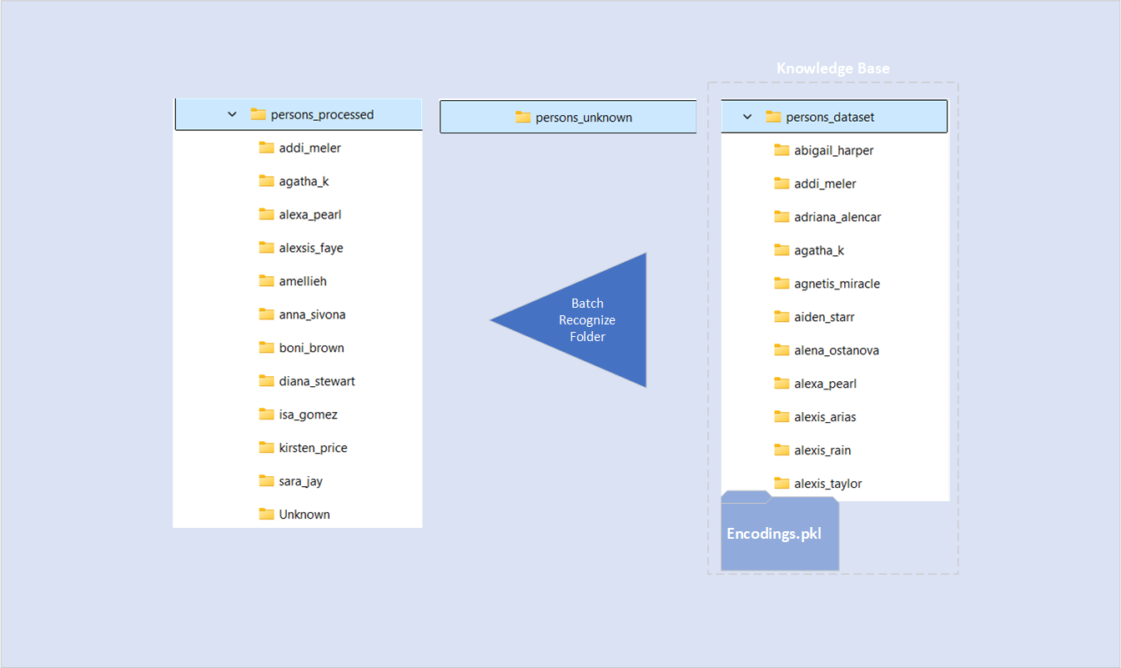

Recognition
As noted already, this post continues our series on encoding and recognition of persons in photo librariess. Earlier, in the previous article we created the knowledge base (KB). A dataset folder containing one subfolder per known person and an encodings.pkl at the root. That file stores the face and body embeddings used for recognition. Now we’ll add batch recognition: process a folder of photos, identify known people, and file each image into an output folder structure by person name. In settings.json this input folder is called process_dir, but you can select any folder from the GUI.

How batch recognition works
We use a dedicated worker class FolderWorker. This runs in its own thread so the GUI stays responsive. The menu item Recognition, Recognize Folder… launches the worker with the chosen input and output folders. The worker streams progress and log messages back to the main window. When finished, it emits a one-line summary.

Pipeline per run
The worker follows these steps.

Validate inputs
Check the input folder, ensure the KB exists, and scan for supported file types. If no images are found, the worker finishes early with a clear message.
Load the KB
Read encodings.pkl and load face/body encodings plus their names into memory.
Initialize the toolkits
Build the TorchReID body feature extractor (quietly) for full-body embeddings. Use the face encoder to detect/align faces and compute face embeddings.
Process each image
Images are opened with context managers to avoid Windows file locks.
Face: detect + align → encode → compute distances to known faces → pick top-3; if the best distance is below face_threshold, assign that name.
Body: extract a body embedding → cosine similarity vs. the body bank → top-3; if the best similarity is above body_threshold, assign that name.
Note: for performance body features are vectorized (cosine similarity is measured in one go).
Final decision: prefer the face result when present; otherwise fall back to body. Unknowns are counted.
Copy the image into output/<person_name>/… or output/Unknown/….
Summarize
Report totals and the percentage of unknowns.

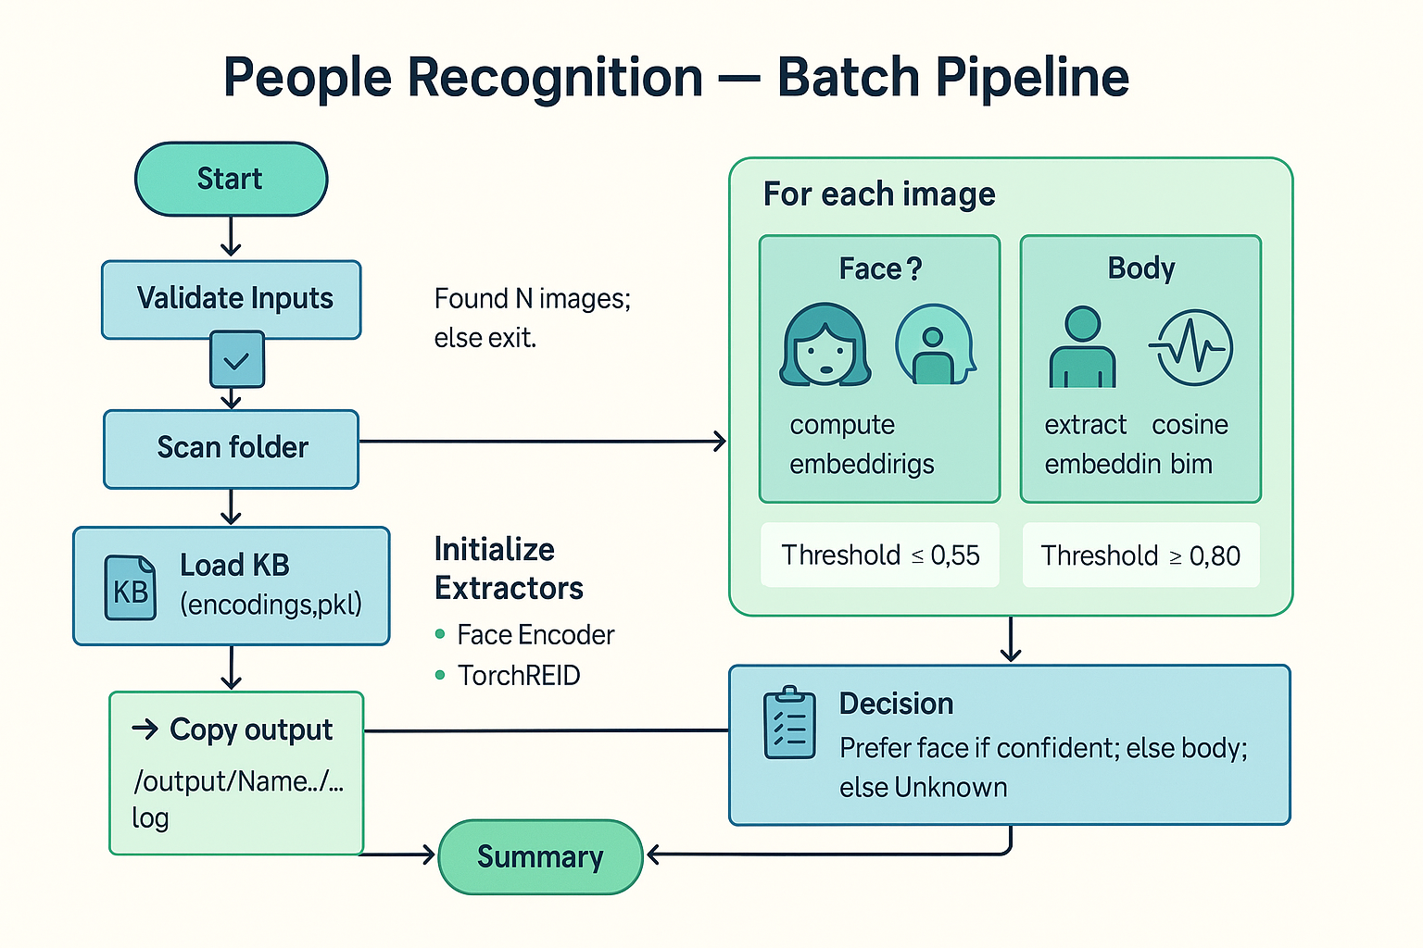

What you’ll see in the GUI
The central console shows the results of the files being process and the final summary. The progress bar shows the progress made.

Thresholds cheat-sheet
Our configuration file settings.json, shown below, contains the thresholds used for face and body recognition.

{
"dataset_dir": "D:/Coding/recognize/posts/app/persons_dataset",
"processed_dir": "D:/Coding/recognize/posts/persons_processed",
"process_dir": "D:/Coding/recognize/posts/persons_unknown",
"face_tol": 0.4,
"body_tol": 0.8,
"reid_model": "osnet_ain_x1_0",
"valid_exts": [".jpg", ".jpeg", ".png", ".webp"],
"encodings_filename": "encodings.pkl",
"resize_max": 800,
"lap_var_thresh": 80.0,
"kb_batch_size": 16
}

It is important to realize these thresholds work in opposite directions. The body threshold measures the degree of correspondence: higher = better; the face threshold however measures the differences: lower = better.

For body recognition 0.8 is rather strict, for face recognition use the following threshold values:
Threshold | Behavior
0.6 | Standard, balanced
0.5 | Strict
0.4 | Very strict (almost identical faces only)
0.35 or lower | Extremely strict — only near-perfect matches

Recognize
The full worker is available here: recognize.py. It includes safe file handling, early-exit checks, and concise logging. After the code you find some suggestions for obvious add-on’s.

# recognize.py
from __future__ import annotations
from pathlib import Path
from PyQt6 import QtCore
from PyQt6.QtCore import pyqtSignal
import os, shutil, pickle, numpy as np, torch
from PIL import Image
import face_recognition
from face_encoder import detect_and_align_faces

class FolderWorker(QtCore.QObject):
progress = pyqtSignal(int)
log = pyqtSignal(str)
finished = pyqtSignal(str)

def __init__(self, kb_path: Path, input_folder: Path, output_folder: Path,
face_threshold: float, body_threshold: float,
reid_model="osnet_ain_x1_0", valid_exts=(".jpg",".jpeg",".png",".webp"), parent=None):
super().__init__(parent)
self.kb_path = Path(kb_path)
self.input_folder = Path(input_folder)
self.output_folder = Path(output_folder)
self.face_threshold = float(face_threshold)
self.body_threshold = float(body_threshold)
self.reid_model = reid_model
self.valid_exts = tuple(e.lower() for e in valid_exts)

@QtCore.pyqtSlot()
def run(self):
try:
# --- validate ---
if not self.input_folder.is_dir():
self.finished.emit("Input folder does not exist.")
return
self.output_folder.mkdir(parents=True, exist_ok=True)

if not self.kb_path.exists():
self.finished.emit("KB encodings.pkl not found. Build the KB first.")
return

# --- scan input FIRST (early exit on empty) ---
files = sorted(
f for f in os.listdir(self.input_folder)
if f.lower().endswith(self.valid_exts)
)
total = len(files)
self.log.emit(f"[Scan] Found {total} files in '{self.input_folder}' (exts={self.valid_exts})")
if not files:
self.finished.emit("No images found in selected folder.")
return

# --- load KB ---
db = pickle.load(open(self.kb_path, "rb")) or {}
known_faces = db.get("face_encodings", []) or []
known_face_names = db.get("face_names", []) or []
known_bodies = db.get("body_encodings", []) or []
known_body_names = db.get("body_names", []) or []
bodies_T = (torch.as_tensor(np.asarray(known_bodies, dtype=np.float32))
if known_bodies else None)

# --- lazy import TorchReID wrapper (use package path if you split modules) ---
from reid_wrapper import TorchreidBodyExtractor # or: from .reid_wrapper import TorchreidBodyExtractor
reid = TorchreidBodyExtractor(model_name=self.reid_model, log_fn=self.log.emit)

unknown_count = 0
for i, fname in enumerate(files, 1):
path = self.input_folder / fname
face_name, body_name = "Unknown", "Unknown"
face_result, body_result = [], []
try:
# ---- FACE (aligned → encode → top-3 by distance)
img_np = face_recognition.load_image_file(str(path))
aligned_list = detect_and_align_faces(
img_np, desired_size=160, resize_max=800, lap_var_thresh=80.0
)
if aligned_list:
best = max(aligned_list, key=lambda d: (d['bbox'][1]-d['bbox'][3])*(d['bbox'][2]-d['bbox'][0]))
chip = best["aligned"]
h, w = chip.shape[:2]
ents = face_recognition.face_encodings(
chip, known_face_locations=[(0, w, h, 0)], num_jitters=1, model="small"
)
if ents and known_faces:
q = ents[0]
dists = face_recognition.face_distance(known_faces, q)
order = np.argsort(dists)[:3]
face_result = [(known_face_names[j], float(dists[j])) for j in order]
if dists[order[0]] < self.face_threshold:
face_name = known_face_names[order[0]]
except Exception as e:
self.log.emit(f"[Face] {fname}: {e}")

try:
# ---- BODY (TorchReID → cosine sim top-3)
if bodies_T is not None and bodies_T.numel() > 0:
with Image.open(path) as img:
feat = reid(img.convert("RGB"))
qT = torch.tensor(feat).unsqueeze(0)
if qT.shape[1] == bodies_T.shape[1]:
sims = torch.nn.functional.cosine_similarity(qT, bodies_T).detach().cpu().numpy()
order = np.argsort(-sims)[:3] # highest first
body_result = [(known_body_names[j], float(sims[j])) for j in order]
if sims[order[0]] > self.body_threshold:
body_name = known_body_names[order[0]]
else:
self.log.emit(f"[Body] Dim mismatch for {fname} (query {qT.shape[1]} vs bank {bodies_T.shape[1]})")
except Exception as e:
self.log.emit(f"[Body] {fname}: {e}")

final_name = face_name if face_name != "Unknown" else body_name
if final_name == "Unknown":
unknown_count += 1

# ---- Copy to output/final_name
try:
out_dir = self.output_folder / final_name
out_dir.mkdir(parents=True, exist_ok=True)
shutil.copy2(str(path), str(out_dir / fname))
except Exception as e:
self.log.emit(f"[Copy] {fname}: {e}")

# ---- Log + progress
f3 = lambda xs: ", ".join([f"{n}:{v:.2f}" for (n, v) in xs])
self.log.emit(f"{fname} → {final_name} | Face: [{f3(face_result)}] | Body: [{f3(body_result)}]")
self.progress.emit(int(100 * i / total))

# ---- Summary
unk_pct = round((unknown_count / total) * 100.0, 2)
msg = f"Batch done. {total} files, Unknown = {unknown_count} ({unk_pct}%)."
# self.log.emit(msg)
self.finished.emit(msg)
except Exception as e:
# Make sure we signal completion on error too
self.log.emit(f"ERROR: {e!r}")
self.finished.emit("Recognition failed. See log.")
return

def abort(self):
self._abort = True

Optional Next Steps
Possible enhancements could include:
- An Abort button (an abort() stub is already present, wire it to set a flag and break the loop).
- A Write CSV report button with per-image results and top-3 matches.
- A Review Unknowns dialog that proposes likely candidates (top-3 face/body) for manual assignment (bases on the .csv report).

